Nepal College of Information Technology
Unit Test 2010

Program : BE – CE/ELX Time : 2 hrs
Semester : Fall (III) FM : 70
Subject : Network Theory PM : 35

1. | a. | In the given circuit, switch K is initially at position 1. The steady state having reached, switch K is changed to position 2. Find particular solution for current in the circuit.  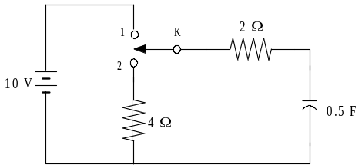  Figure: 1 | [8]
 | b. | In the given circuit, switch is closed at time t=0, the steady state condition having reached previously. Obtain expression for the current in the circuit at any time t. If R1 = R2 = 100Ω, V = 10 V and L = 1 H, calculate at time t = 5 ms (i) current in the loop, (ii) voltage drop across R2 and (iii) voltage across L.  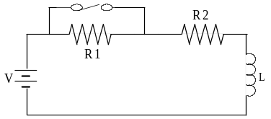  Figure: 2 | [7]
2. | a. | In the given circuit, switch K is changed from position 1 to 2 at time t=0, steady state condition having reached before switching. Find: i, di/dt, d²i/dt² and d³i/dt³ at t = 0+.  [R = 1 Ω, L = 1H, C = 1 μF and V = 10 V]  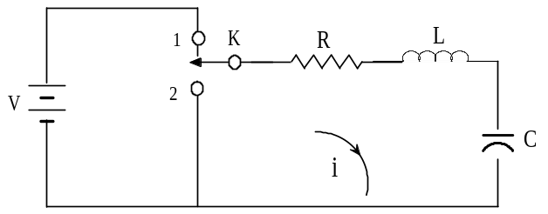  Figure: 3 | [8]
 | b. | In the given circuit, switch K is changed from position 1 to 2 at time t=0, steady state condition having reached before switching. Find: i, di/dt and d²i/dt² at t = 0+.  [R = 10 Ω, L = 1H, C = 1 μF and V = 20 V]  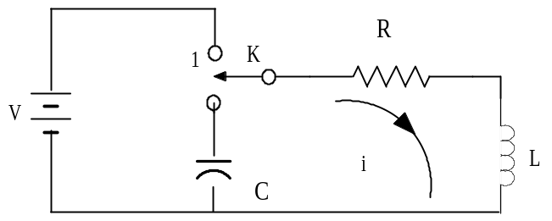  Figure: 4 | [7]
3. | a. | In given circuit, switch is opened at t = 0. It is given that R = 1/7 Ω, L = 1/12 H, C = 1 F and I = 10 A. Obtain particular solution for v(t). Calculate the value of voltage v at t = 0.1 sec.  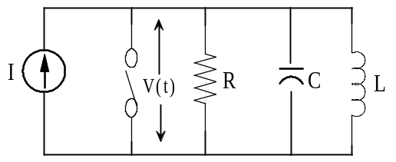  Figure: 5 | [8]
 | b. | In given circuit, switch is closed at t=0. Obtain the general solution and particular solution for i(t) and also the value of i(t) at t = 0.1 sec.  [R = 7 Ω, L = 1 H; C = 0.1 F and V = 10V]  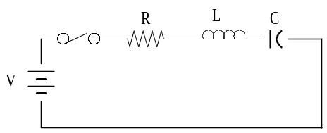  Figure: 6 | [7]
4. | a. | An exponential voltage v(t) = 4 e^{-5t} is applied at time t = 0 to a series RC circuit comprising of resistor R = 0.2 Ω and capacitor C = 1F. Obtain the particular solution for current i(t) through the circuit. Assume that steady state condition has reached in the RC circuit before application of voltage. | [8]
 | b. | In the given circuit, capacitor C has an initial voltage Vc(0-) = 10V and at the same instant, current in the inductor L is zero. Switch k is closed at time t = 0. Find the particular solution for v(t). [R = 1/4Ω; L = 1/3 H; C = 1F]  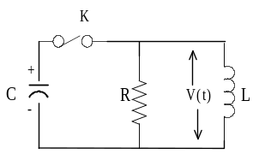  Figure: 7 | [7]
5 | a. | In the given circuit, switch is opened at time t = 0. Find V_{k} at t = 0+. [R₁ = R₂ = 1 KΩ; L = 1H and V = 5 V ]  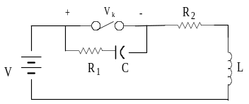  Figure: 8 | [5]
 | b. | Write short note on (any one)  - Time constant of RC series circuit.  - Behavior of inductor on application of voltage. | [5]

